HOPE_logo.tifHouseholders’ Options to Protect the Environment Inc.

PO Box 6118 – Clifford Gardens, Toowoomba QLD 4350

(22 Vacy Street, Toowoomba QLD 4350)

Ph 07 4639 2135; Email: [office@hopeaustralia.org.au](mailto:office@hopeaustralia.org.au)

Website: <http://www.hopeaustralia.org.au>

ABN 48 036 173 161

**Think Globally. Act Locally!**

**Notice and Agenda for 4th Ordinary Meeting – Saturday, 14 June 2025**

*(Last updated – 7 June 2025)*

**Venue: HOPE office, 22 Vacy St, Toowoomba | Time: 10.00am (approx.)**

**Note: If unable to attend the meeting in person or via Zoom and would like your vote recorded, please assign your proxy vote to either Anna Kula-Kaczmarski (President), Kerry Kruger (Secretary) or Miriam Sharp (Treasurer).**

**ZOOM link:**

<https://us06web.zoom.us/j/2448320576?pwd=ay9PUUhDSTBSM2cxV3BNUGdtclEydz09&omn=87944990266>

1. **Meeting started at:** 10am
2. **Introductions, attendees, apologies and morning tea provided**
   1. Attendees:
      1. Physical:
      2. ZOOM:
   2. Apologies:
   3. Proxy votes:
3. **President’s Report**
4. **Office Manager’s report**
5. **Treasurer’s Report:**

**Opening balance as at 7 February 2025 = $2,539.82**

HOPE General Account balance as at 31 May 2025 = $2,616.76

HOPE Gift Fund balance as at 31 May 2025 = $5,332.41

**Closing balance as at 31 May 2025 = $7,949.17**

1. **Social media and website tracker report**

* See reports from Charmaine/Shuri and Yaoyao and Website Summary Tracker (Jan-Mar 2025)

1. **General business**

* Carried forward items from Ordinary Meeting of 8 February 2025
* Actions completed:
  + Issued ‘stock image’ list to Admin Support Team *🡪 Done 11/02/25*
  + Monthly statistics on website traffic to be generated automatically *🡪 Done*
  + Encourage members of Admin Support Team and our envNGO network to contribute posts to our Social media platforms *🡪 Done*
    - Review of government responses re Abandoned mines in their respective jurisdictions *🡪 Report prepared - 4 March 2025*
* Actions still pending:
  + Report from President re Tracking progress of Strategic Plan matters (see draft attachment)
  + Proposed ‘ZOOM’ interview of our Patron – Jerry Coleby-Williams *🡪 Reassigned to Andrew Nicholson. Awaiting suitable date & time to conduct interview.*
* Progress made in implementing consultant’s suggested improvements to Social Media and Website management practices *🡪 Completed items ‘ticked off’’ on input documents*
  + - Updating of Ecological Footprint PPT (by Lizzie Pennington) *– in progress*
    - Delivery of 2 FREE drone flyers for Friends of the Escarpment Parks (FEP) Toowoomba (by Ben Sparshott) *– awaiting dates from FEP personnel*
* Review of responses from Australian universities re their environmental policies 🡪*Assign to researcher*
* Prepare ‘specially themed’ editions of newsletter *🡪 3 editions already published*
* Continue chasing sponsorships *🡪 with a focus on finding a financial benefactor*
* Request for help with Membership and Volunteer Management issued in Office Update (28/03/25)*🡪 No responses to date*
  + Report on Logan Eco Action Festival (LEAF) event 2025
* Westpac bank accounts *🡪 Slow progress changing to debit card and online banking access. Awaiting further appointment with bank to finalise paperwork.*
* *HOPE General Account banking changes approved (23 March 2025)*
* *HOPE Gift Fund banking changes approved (15 May 2025)*
* Grants/Projects – current & proposed:
* Current grants:
  + - Purchase 2 laptops; and the upgrade of our website *– 31/11/24 - submitted online grant application to QLD Gambling Community Benefit Fund (GCBF)*
* *Unsuccessful (7 May 2025). Investigate a GoFundMe option.*
  + - Governance training *🡪 29/11/24 - Submitted online application to Qld Gives*
      * *Successful (28 April 2025)*
    - Development of booklet & podcasts of male “Environmental Champions of our Region”

*29/11/24 – Submitted EoI to Judith Neilson Institute Grants 🡪 Issued further request on 8 Mar 2025*

* + - * *18/01/25 - Investigate* [*Home - Australian Communities Foundation*](https://www.communityfoundation.org.au/)*; and/or a Go Fund Me platform*
* Current projects:
  + - 2nd University Student Placement – re: [**Co-building a new eco-social world: leaving no one behind.**](https://newecosocialworld.com/)
    - Andrew’s podcast series entitled “*A preferred future by 2050: credible pathways toward a life-enhancing community in South East Queensland”*
      * *Andrew proposes to produce 1 or 2 pilot podcasts to promote the larger project. Supported by all attending*
      * *Office and Social Media team to assist with promotion of these pilot podcasts*

1. **Next ordinary meeting** – 14 September 2025
2. **Meeting closed at:**

**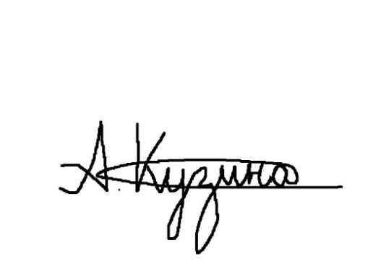 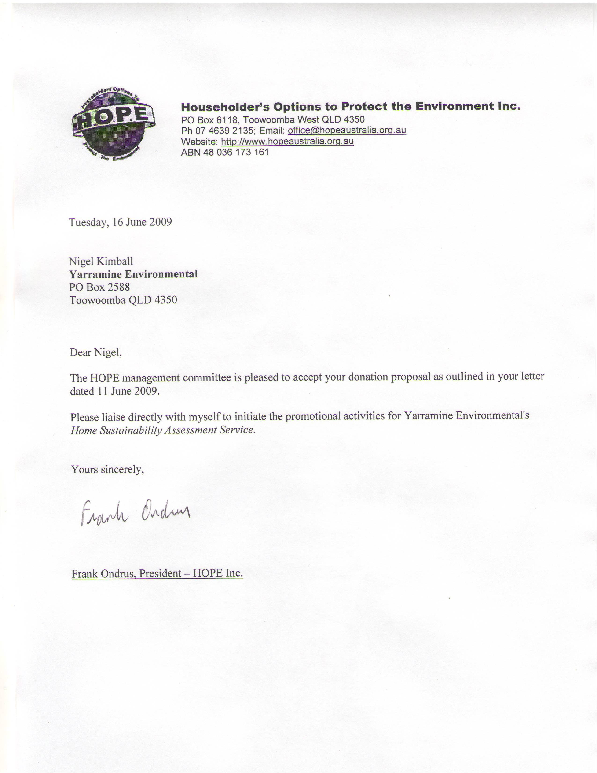**

**Anna Kula-Kaczmarski (President) Frank Ondrus (Officer Manager) – minutes taker**

**14 June 2025**