**HOPE_logo.tifHouseholders’ Options to Protect the Environment Inc.**

PO Box 6118 – Clifford Gardens, Toowoomba QLD 4350

(22 Vacy Street, Toowoomba QLD 4350)

Ph 07 4639 2135; Email: [office@hopeaustralia.org.au](mailto:office@hopeaustralia.org.au)

Website: <http://www.hopeaustralia.org.au>

ABN 48 036 173 161

**Think Globally. Act Locally!**

**M E D I A R E L E A S E**

Sunday, 12 January 2025

**Help HOPE promote sustainable living in your community!**

*Are you concerned about the environment and looking for ways to create a more sustainable future?*

**HOPE (Householders’ Options to Protect the Environment)** is here to **support your community** in its journey towards sustainable living. By providing access to valuable resources and practical advice, HOPE empowers **individuals and communities** to embrace eco-friendly practices and make a real difference.

**HOPE’s slogan is *“Think Globally - Act Locally”***

**Extensive Resource Library:**

|  |  |
| --- | --- |
| [**eNews Bulletins**](https://www.hopeaustralia.org.au/home/enews-bulletins/) | Downloadable monthly newsletters filled with the latest news and sustainability tips. |
| [**Cooperative Hints**](https://www.hopeaustralia.org.au/resources/helpful-hints/) | Practical advice on a broad range of topics  related to sustainable living. |
| [**Podcasts**](https://www.hopeaustralia.org.au/resources/podcasts/) **&** [**YouTube**](https://www.hopeaustralia.org.au/resources/youtube-current/) **Videos** | Engaging audio and visual content on environmental issues. |
| [**envNGOs networks**](https://www.hopeaustralia.org.au/resources/envngo-networks/) | A directory of conservation organisations  operating across Australia. |
| [**Sundry – HOPE**](https://www.hopeaustralia.org.au/resources/sundry-hope/) **&** [**Media Releases**](https://www.hopeaustralia.org.au/resources/media-releases/) | A variety of HOPE’s own publications and media activities  to promote sustainable living. |

**Get Involved**Membership to HOPE is **free and open to all**, including individuals, families, businesses, and community organisations. By joining HOPE, you’ll gain access to valuable resources that help promote environmental sustainability in your community.

* [**Membership Information**](https://www.hopeaustralia.org.au/membership/)
* [**Projects and Events**](https://www.hopeaustralia.org.au/projects-events/)
* [**Volunteering Form**](https://www.hopeaustralia.org.au/membership/volunteer-form/)

**Join HOPE Today!**

To learn more, visit [hopeaustralia.org.au](https://www.hopeaustralia.org.au) and explore our full range of resources.

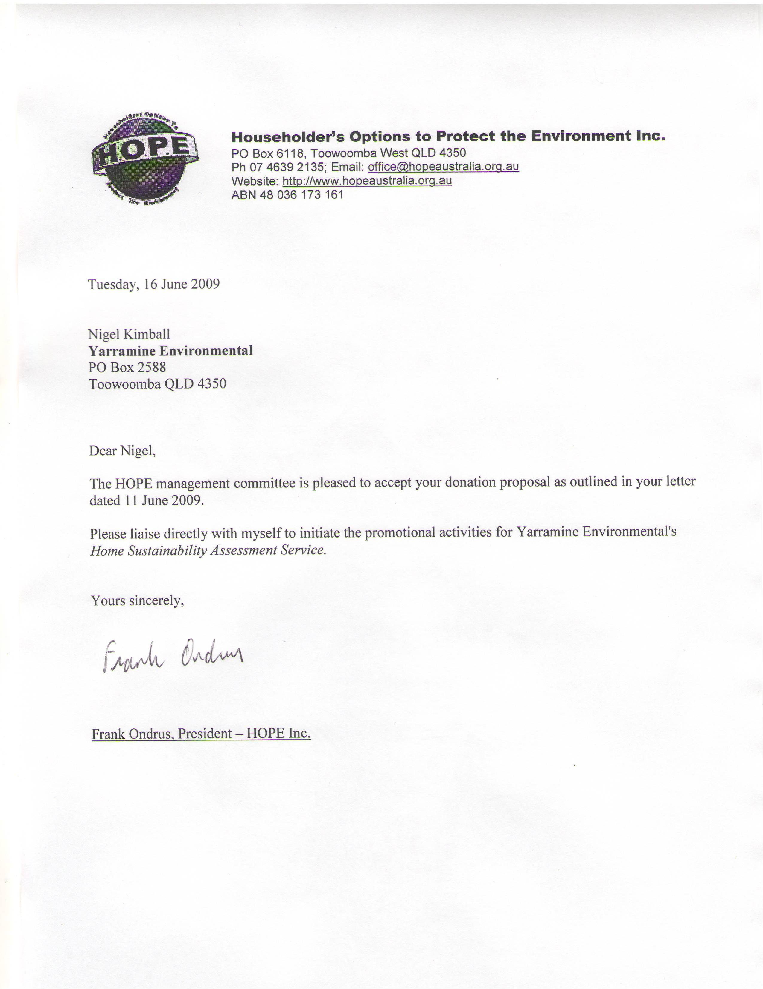

Frank Ondrus, President – HOPE Inc., ph. 07 4639 2135

*Written by Shuri Matsumoto - Media Officer (ACT)*