**The Earth Charter: Humanity’s map to a sustainable future**

*Written by Josephine Jarvis, HOPE researcher NSW*

***"The final chapter is ours to write. We know what we need to do. What happens next is up to us.” - David Attenborough***

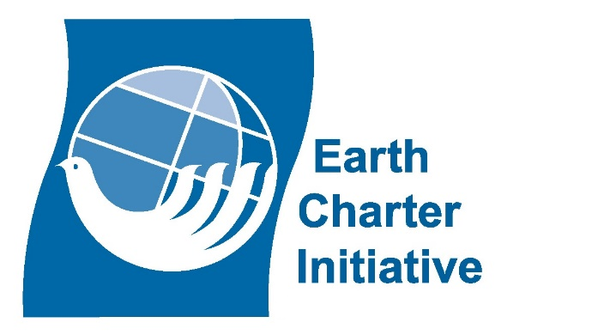The [Earth Charter](https://earthcharter.org/) is an ethical framework for achieving a sustainable, peaceful and just future for all of Earth’s inhabitants. In 1987, the World Commission on Environment and Development called for the creation of a charter to direct a shift towards sustainable development. Thirteen years later, in the year 2000, the Earth Charter was officially launched. Developed by the Earth Charter Commission, formed by global representatives, the document sets a foundational path forward underpinned by the biggest concerns facing the Earth and its ecosystem today, and, more importantly, tomorrow. The Earth Charter consists of four focus areas, or “pillars,” which branch into 16 key principles from which humanity must take action on as a matter of universal responsibility. There are countless organisations globally that recognise this duty and respond through their own efforts, guided by the Charter and its principles.

The Earth Charter begins with four foundational principles that flow from the primary pillar of respecting and caring for the community of life. The principles are the interdependence of all life; love and responsibility; democracy and freedom; and justice across generations. The Earth Charter International (ECI) is an organisation that takes the Charter’s recommendations and empowers them with action. It does so by providing information, networking links and education. It aims to promote the Earth Charter as an “ethical reference” and laments the need to turn it into action, such as by integrating the document into educational and legal settings.

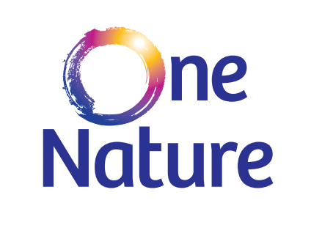

The Earth Charter’s second pillar is ecological integrity, which focuses on the health of the Earth’s physical environment, as well as our impactful and interconnected relationship with it as its inhabitants. The [OneNature Institute](https://onenatureinstitute.org/), a non-profit organisation founded in 2020, recognises the importance of ecological integrity principles by advocating for conservation efforts that promote its importance for community well-being. The organisation acts on these principles through three primary initiatives.

The first is a program called ‘Deepening the Connection,’ which encourages individuals to develop a personal bond with the environment through practices such as conservation volunteering and spending mindful time in nature, provoking granular action towards both the Earth Charter’s fifth principle of protecting Earth’s diversity, and its ninth principle that encourages the adoption of sustainable lifestyles.

The second initiative, the ‘Wild Happiness projects,’ links conservation efforts with communities by offering certifications that highlight the interconnectedness of human and wildlife well-being, a function that aligns accountability of the Earth Charter’s sixth principle of preventing ecological harm, on an institutional level.

Finally, OneNature strives to transform conservation efforts by prioritising human well-being, engaging in actions such as holistic policy advocacy, collaborative research, and deploying initiatives through a well-being lens. These efforts contribute towards the Earth Charter’s eighth principle to share knowledge, in cooperation with the international community. OneNature is an organisation turning ideals into tangible actions, advancing the goals of ecological integrity set out in the Earth Charter.

The third pillar of Earth Charter is social and economic justice, which addresses human rights issues around poverty, equity and dignity. [Amnesty International](https://www.amnesty.org.au/) is an organisation that works to address this pillar and its recommendations. Active in over 150 countries and territories, it seeks to take action against a wide range of issues relating to human rights. The organisation acts by conducting thorough research, leading campaigns, challenging laws and fighting for people who have been wrongfully persecuted. Amnesty holds governments and other parties accountable for their actions and inactions around human rights. The organisation conducts campaigns that align with various principles of the Earth Charter.

Amnesty is making efforts towards the Earth Charter’s ninth principle to eradicate poverty, through a petition to the UN Special rapporteurs calling for decriminalisation of poverty and the right for all to safe housing. It lobbies against criminal charges for behaviours relating to homelessness, such as loitering, street vending or sleeping in public places, as well as encouraging investment into sustainable tactics toward more equitable housing standards.

The Earth Charter’s tenth principle of equitable human development is put into action by Amnesty’s campaigns against Indigenous justice. The petition ‘Kids don’t belong in prison cells’ addresses the government’s recent promises to lower the age of criminal responsibility to 10 years of age and reintroduce spit hoods in Queensland and the Northern Territory, the latter an action that has previously been considered torture by the United Nations. Amnesty warns governments not to breach human rights law in their treatment of vulnerable youth communities.

The eleventh principle of the Earth Charter addresses gender equality and equity, calling for the upholding of the rights of women and girls. Amnesty has several active women’s rights campaigns, including calls to protect individuals from persecution on the base of gender, or for speaking out about gender injustices. One petition is called ‘Saudi Arabia: release student jailed for 34 years for tweets’ brings a voice to Salma al-Shehab, a woman who was sentenced to 34 years in prison for using Twitter to discuss and support women’s rights activists.

The Earth Charter’s twelfth principle, dignity, inclusion and well-being, calls to eliminate discrimination based on human differences, including, but not limited to, race, religion and sexual orientation. Amnesty International campaigns against all types of prejudice based on diversity. One example, relating to sexual orientation, is its petition to ‘stand with survivors of conversion practices,’ prompted by research showing that 10% of LGBTQIA+ Australians are at risk of having these practices imposed on them. Amnesty International exemplifies organisational action and reform guided by the Earth Charter’s pillar of social and economic justice.

The Earth Charter’s final pillar champions democracy, nonviolence and peace in culture, education, governance, as well as wider society. The [Women’s International League of Peace & Freedom](https://www.wilpf.org.au/) (WILPF) is a global feminist organisation working towards peace through demilitarisation founded in ideas aligned with the Earth Charter.

The Australian branch of WILPF works towards the thirteenth Earth Charter principle of transparency and participation in its promotion and monitoring of Australia’s first Women, Peace and Security National Action Plan (NAP) development, which aims to hold the government accountable for its performance in these areas.

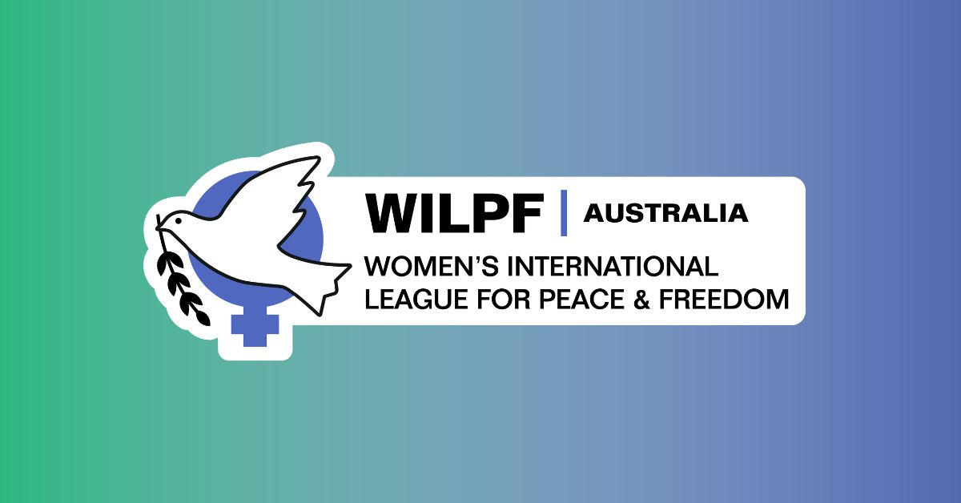

The fourteenth Earth Charter principle, integration of values into education, outlines the importance of formal education in developing a sustainable future. The Australian branch WILPF embodies this point in its petitioning to stop what it calls the militarisation of schools in ways such as the Nuclear-Powered Submarine Propulsion Challenge, which was introduced to the country’s schools in 2023. WILPF argued the program, which invited students to learn more about the defence aligned topic, “brainwashed” students about war being an avenue to conflict resolution.

WILPF’s ‘Campaign to Stop Killer Robots,’ as well as its wider lobbying to establish a treaty banning autonomous weapons, links with the fifteenth Earth Charter principle to respect all living beings. WILPF calls to prevent the weaponisation of artificial intelligence, with concerns about the dehumanisation of people from a machine’s perspective, which may result in worsened repercussions for marginalised groups by categorising them without empathy or accuracy.

WILPF contributes to the cause of nonviolence and peace that is the sixteenth Earth Charter principle, by its work in the Middle East and North Africa (MENA). The organisation aids in efforts to include women in peace and security processes in the region through the Women, Peace and Security (WPS) agenda, a motion that advocates for the prioritisation of human security above militarised security.

The Earth Charter unites us as global citizens to work together, both in an organisational capacity, and in our individual efforts, towards the unifying goal of sustaining a planet that can be home to all living things into the far distant future. The pillars and their principles allow for a comprehensive plan of attack against the main issues posing a threat to this goal. It is through the work of dedicated organisations, and the individual actions spurred from their efforts, that the Earth Charter is brought to life. The united framework affords a cohesive implementation of actions, as demonstrated in the campaigns and initiatives of these organisations. We may have a long way to go in securing a sustainable, peaceful and just future on Earth, but at least we have a map!

**Reference List**

* Amnesty International, https://www.amnesty.org.au/
* Earth Charter, https://earthcharter.org/
* Earth.Org, https://earth.org/david-attenborough-quotes/
* OneNature Institute, https://onenatureinstitute.org
* WILPF Australia, https://www.wilpf.org.au
* WILPF, https://www.wilpf.org/